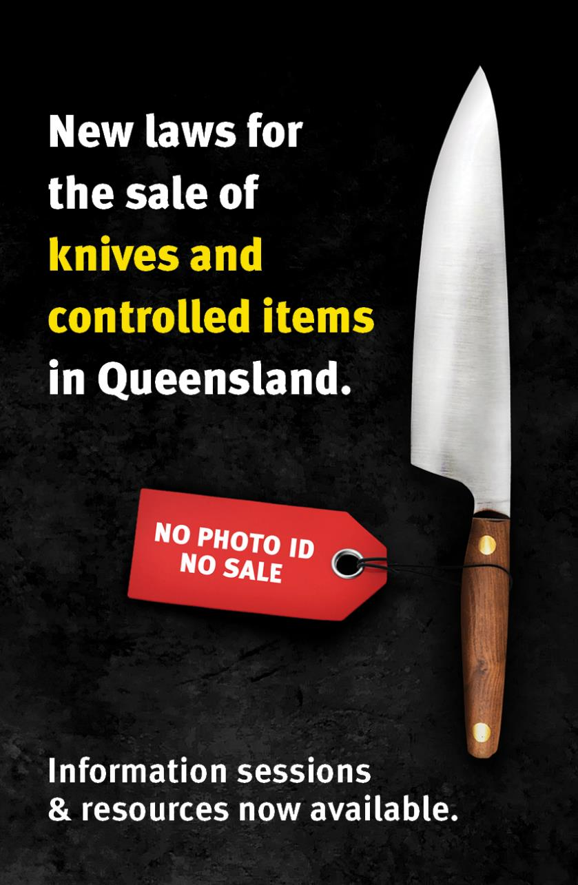

BUSINESS COMMUNICATIONS KIT
Sharing information with sellers in your network
Table of Contents
Overview of new legislation 3
Purpose of this kit 3
Spread the word 3
Public & community awareness​ 3
Support services available 4
Key resources to share 4
Sample content to help spread the word to businesses 5
1. Sample Email to Businesses and Sellers 5
2. Sample Web Content 6
3. Sample Social Media Posts 7
Have questions? 8
About the National Retail Association 8

This kit is provided in Microsoft Word format so you can copy, paste and edit messaging to your needs.
Please note that logos of the Queensland Police Service, Queensland Government and National Retail Association cannot be used without permission, except in finished resources provided.

Overview of new legislation
New laws come into effect in Queensland from 1 September 2024 meaning knives and other items will be considered controlled items.
Summary of requirements for sellers:
- You must not sell knives or controlled items to anyone under 18.
- You must display signage regarding age restriction requirements.
- You must instruct and warn staff, with written acknowledgement.
- You must not promote or advertise controlled items as 'suitable for combat'.
- You must securely store particular controlled items prior to sale.
  - Single-edged knives must not be sold to minors, but are not required to be securely stored, unless this is the policy of your business.
  - Particular controlled items are required by law to be securely stored: double-edged knives, knives with blades at both ends, axes, tomahawks, machetes, sickles, scythes, swords, spears, spear guns and gel blasters which look like real firearms.

Purpose of this kit

Spread the word
Help sellers prepare for new QLD knife sale laws.
It is important that as many businesses as possible are aware of the laws and the free support services available.​
The National Retail Association has been officially engaged by the Queensland Police Service to educate and assist businesses to understand, prepare for and comply with the new legislation. National Retail will be delivering a range of support services for businesses, including a tollfree hotline, factsheets and signage, online information sessions, and physical visits to thousands of stores in over 500 retail centres and precincts across QLD.
This kit includes a range of sample communication materials for you to share with businesses in your network to help spread the word about the laws and the free support services available.
Please help spread awareness across your networks using the sample resources provided in this kit.

Public & community awareness​
The Queensland Police Service is responsible for implementing and enforcing the legislation, as well as community and non-business education. ​
To spread awareness, QPS has launched an “End Knife Violence” campaign aligned to new laws restricting the sale of knives and other controlled items. Please refer to the QPS website for resources designed to assist with public awareness and education: endknifeviolence.com.au

Support services available
The National Retail Association has been officially engaged by the QLD Government to help educate and assist businesses to understand and prepare for the new legislation restricting the sale of knives and other controlled items coming into effect from 1 September 2024.
We are delivering a range of services including:​
- Visiting thousands of businesses in 500 shopping centres and retail precincts across QLD
- Website for businesses: https://bit.ly/knifelaws-nationalretail
- Sellers Guide, factsheets & posters: resources menu
- Online information sessions: https://bit.ly/qldknifelaws
- Tollfree hotline: 1800 571 146
- Email: policy@nationalretail.org.au
All these services are free-of-charge to businesses, funded by the Queensland Police Service. You do not need to be a retailer or National Retail Association member to access these services.​
Dedicated private briefings to large businesses, peak bodies and distributors:
- Email us to request a briefing.

Key resources to share
The Guide for Sellers and National Retail website both provide businesses with the same essential information they need on what’s changing, steps to compliance and FAQs. The website also offers a large range of signage and other resources.
Please direct businesses to the website in all communications.​
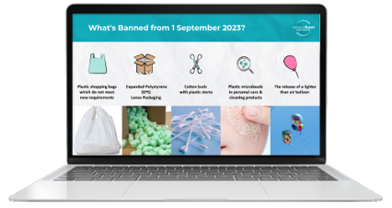  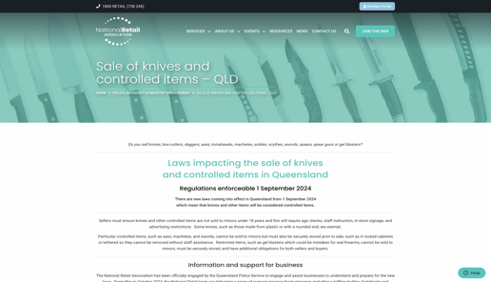 | 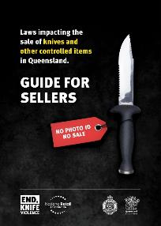 | 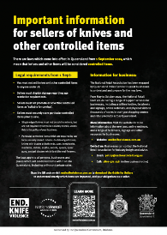
Website for business with all resources | Guide for Sellers | Basic Factsheet
https://bit.ly/knifelaws-nationalretail | Download here > | Download here >

Sample content to help spread the word to businesses

Sample Email to Businesses and Sellers
Subject: Important Update: New QLD Knife Sale Legislation Effective 1 September 2024
Dear XXX,
We are writing to inform you about important new legislation coming into effect in Queensland on 1 September 2024, which will impact the sale of knives and other controlled items.
Key requirements for sellers:
- Knives and other controlled items cannot be sold to anyone under the age of 18.
- Sellers must display signage about age restriction requirements.
- Staff must be instructed and warned of their obligations, with written acknowledgement.
- Controlled items must not be promoted or advertised as suitable for combat.
- Certain controlled items, such as double-edged knives, machetes, tomahawks, and axes, must be securely stored prior to sale.
The Queensland Police Service (QPS) will be responsible for implementing and enforcing these new laws, including conducting compliance checks and expanding wanding operations.
To help you prepare for these changes, the National Retail Association has been officially engaged by QPS to provide a range of support services for business, including a toll-free hotline, factsheets, signage, online information sessions, and thousands of instore visits.
For more information and to access these resources, please visit:
- Business website: https://bit.ly/knifelaws-nationalretail
- Online Info Sessions (Every Thursday 11am): https://bit.ly/qldknifelaws
- Hotline: 1800 571 146
- Email: policy@nationalretail.org.au
Please take advantage of these free services and resources to ensure your business is compliant with the new regulations.
----------------

Recommended attachment: Basic Factsheet

Sample Web Content
Important Notice: New QLD Knife and Controlled Item Laws Effective 1 September 2024
From 1 September 2024, new laws will be enforceable in Queensland regarding the sale of knives and other controlled items. These changes are designed to reduce weapon accessibility among young people and deter knife crime.
Key points for sellers:
- Knives and other controlled items cannot be sold to anyone under the age of 18.
- Sellers must display signage about age restriction requirements.
- Staff must be instructed and warned of their obligations, with written acknowledgement.
- Controlled items must not be promoted or advertised as suitable for combat.
- Particular controlled items, such as double-edged knives, machetes, tomahawks, and axes, must be securely stored prior to sale.
The Queensland Police Service (QPS) will enforce these laws and conduct compliance checks.
The National Retail Association has been officially engaged by QPS to provide a range of support services for business, including a toll-free hotline, factsheets, signage, online information sessions, and thousands of instore visits.
For more information, visit https://bit.ly/knifelaws-nationalretail or contact National Retail at 1800 571 146.
----------------
Sample website banner:
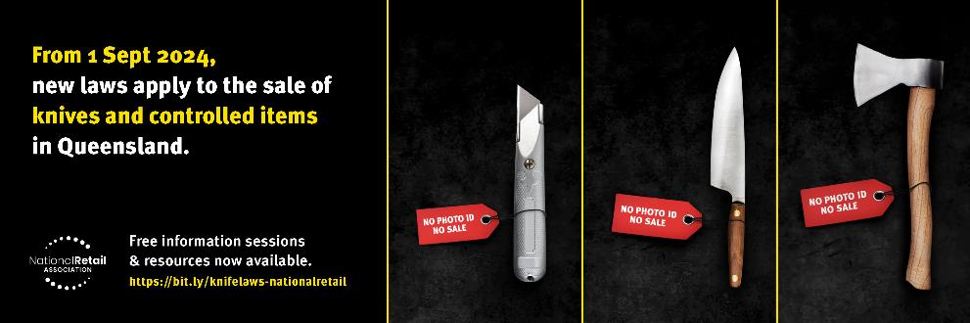

Sample Social Media Posts
Post 1: 🚨 Attention QLD Retailers! 🚨 New laws effective from 1 September 2024 will restrict the sale of knives and controlled items to anyone under 18. Make sure your business is ready! For business support and resources, visit https://bit.ly/knifelaws-nationalretail or contact the National Retail team at 1800 571 146. #EndKnifeViolence #QLDKnifeLaws #RetailerSupport

Post 2: 🚨 Attention QLD Retailers! 🚨 New laws effective from 1 September 2024 will restrict the sale of knives and controlled items to anyone under 18. Make sure your business is ready! Free weekly info sessions every Thursday: https://bit.ly/knifelaws-nationalretail #EndKnifeViolence #QLDKnifeLaws #RetailerSupport

Post 3: 🛑 From 1 September 2024, knives and other controlled items cannot be sold to minors in QLD. Retailers must display age restriction signage and securely store specific items. Learn more about these changes and get support from the National Retail Association. Visit https://bit.ly/knifelaws-nationalretail for details. #EndKnifeViolence #QLDKnifeLaws #RetailerSupport

Post 4: New knife sale laws in QLD come into effect on 1 September 2024. Ensure your store complies with the new regulations to avoid penalties. The National Retail Association offers free resources and support. Check out https://bit.ly/knifelaws-nationalretail for more information. #EndKnifeViolence #QLDKnifeLaws #RetailerSupport

Post 5: QLD’s new knife laws start 1 Sept! No sales to minors, secure your stock, and stay compliant. Access business help at https://bit.ly/knifelaws-nationalretail #EndKnifeViolence #QLDKnifeLaws #RetailerSupport

----------------

Sample social media images:
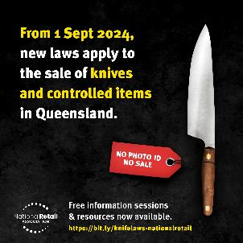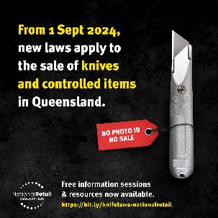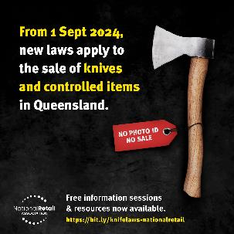

Have questions?
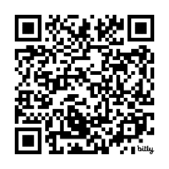
For more information and support, please:
- VISIT: https://bit.ly/knifelaws-nationalretail
- REGISTER: https://bit.ly/qldknifelaws
- EMAIL: policy@nationalretail.org.au
- CALL: 1800 571 146

About the National Retail Association
Who are we
The National Retail Association is Australia’s most representative retail industry organisation, servicing more than 60,000 retail and food outlets nationwide.
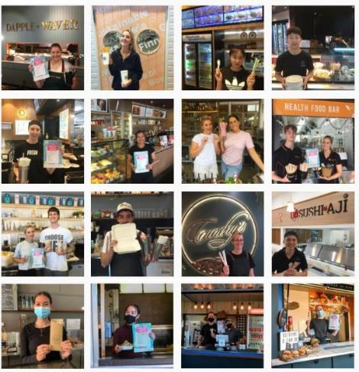
We are a not-for-profit organisation built on strong relationships with our members and for almost 100 years we have been helping our member businesses navigate and comply with a complex and evolving regulatory environment.
What we do

- Safe Retail Precincts
- Safe City Networks
- Retail Crime Committees
- Customer aggression
- Sustainability
- Single-use Plastic Bans
- Trading Hours
- Product safety
- Health & nutrition

We relay industry perspectives to government to inform regulations and policy decisions. We also engage businesses to ensure they understand and can comply with regulations, while minimising impact on business operations.

